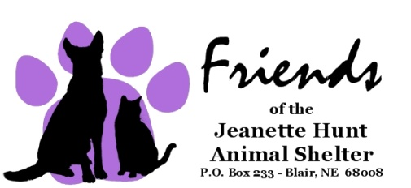
Foster Care Volunteer Application

Name:
Address:
City: State: Zip:
Phone: Best Time to Call:
Alternate Phone:
Email Address:
Divers License Number: State:
How long at current address? Rent Own
I live in: (circle one) House Condo/Apartment Duplex Mobile Home Other
If you rent, may we contact the owner to obtain permission for this foster care animal to live in your home?
Yes No
Owners Name: Phone:
If less than one year at present address, please provide previous address:
Address:
City: State: Zip:

Are you 18 years of age? Yes No
List all pets currently in your household, including roommate’s pets:
Name/Type | Color/Breed | Age | Sex  M/F | Altered  Y/O | Other (Declawed, FIV, Etc.) | Micro Chipped  Y/N

Current vet’s name:
Clinic name: Phone #:
Can your vet verify the current vaccination history on your present pets? Yes No

Have you volunteered or adopted from the Friends of the Jeanette Hunt Animal Shelter in Blair, Nebraska before? Yes No

As the Foster Care Volunteer I agree to the following provisions:
____I understand that only spayed and neutered animals are released for adoption after foster care.
____I agree to provide the foster care animal with necessary inoculations at the intervals advised by JHAS Staff.
____I agree that the foster care animal’s primary living arrangements will be indoors and that a proper carrier will be used when transporting the adopted pet outside the confines of my property.
____I agree to not abuse or neglect the foster care animal, and I authorize the Friends of the Jeanette Hunt Animal Shelter in Blair, Nebraska at its sole discretion, to determine whether or not the animal has been abused or neglected. Foster care animals can be removed from your home at any time at the discretion of JHAS Staff.
Remedy for noncompliance:
It is agreed the Friends of the Jeanette Hunt Animal Shelter in Blair, Nebraska retains superior title in said animal limited to and for the express purpose of assuring the animal's well-being and will only exercise its superior claim in the event it appears to the Friends of the Jeanette Hunt Animal Shelter that the proper and humane care as specified in the above Foster Care Agreement provisions is not being afforded to the said animal, in which case the animal may be taken through a Claim and Delivery proceeding.

Signature of Foster Care Volunteer:
Printed Name of Foster Care Volunteer:
Date: ____________________
Home Visit Date _________________________Time_____________________________

